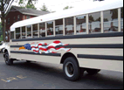
TROOP 243
June 1st, 2016
Boy Scouts of America
Chartered by St. John Paul II Catholic Church
3044 Hikes Lane Louisville, Ky 40220
3521 Goldsmith Lane http://www.troop243.com

Troop 243 Outings & Activities – Among other things in June, our Philmont Crew will depart for one of the premium experiences available in scouting, the Philmont hike. This is one of the unique big 3 or 4 activities for which BSA is famous. Summer camp is this month where we will earn quite a few merit badges. St. John Paul II will also have their annual picnic and we will help with parking and clean up.

Troop and Patrol Meetings on Wednesdays - All are welcome. Scouts in Field/Class A uniforms are expected for all troop meetings while class B uniforms are ok for patrol meetings. Except where noted, all meetings are held at St. St. John Paul II’s Hikes Lane Campus. SERVICE PATROLS should arrive 15 minutes early to set up for the meeting.

June 1st, 7:00 PM – Patrol Meeting – Organize and set up tents
June 8th, 7:00 PM – Patrol Meetings – Summer Camp and Picnic prep
June 15th, 7:00 PM – No troop meeting due to summer camp
June 22nd, 7:00 PM – Troop Meeting – Engineering Merit Badge
June 29th, 7:00 PM – Troop Meeting – Engineering Merit Badge

Summer Camp – Welding, Kayaking, Fishing, swimming and all sorts of fun stuff will be the order of business this summer! This year, after a few year of visiting other council camps, we return to Crooked Creek for our summer camp. Our scouts are signed up for a full complement of merit badge classes which should allow them all to make great progress and learn a lot. You can expect our anniversary Court of Honor to be full of merit badge recognition!

St. John Paul II Parish Picnic – Our sponsor, St. John Paul II parish, hosts a summer picnic on June 9, 10 and 11th at the Goldsmith Lane Campus. As always, we are committed to support the parish in any way we can which includes directing traffic and helping to clean up afterwards. As was true last year, all scouts are expected to participate and this participation (or lack thereof) will be heavily weighted as we calculate the awarding of spirit points as of June 31st this year. Everybody come out and have some fun! Here is where you can sign up to work - http://www.signupgenius.com/go/10C0A4AA9AA22AAFE3-stjohn

Philmont Trek – At the end of June, we will send a crew of scouts off to participate in BSA’s Philmont Trek. This is one of BSA’s outstanding outdoors experiences that allow scouts to truly explore and experience nature. Our crew departs June 27th and returns July 10th. A big congrats to all who get to participate!

Troop Leadership Meetings – Troop Leadership Meetings will be held on the regular days this month. The PLC meets on Sunday, June 26th while the adults will meet from 7-9 Monday June 27th. Everyone is invited.
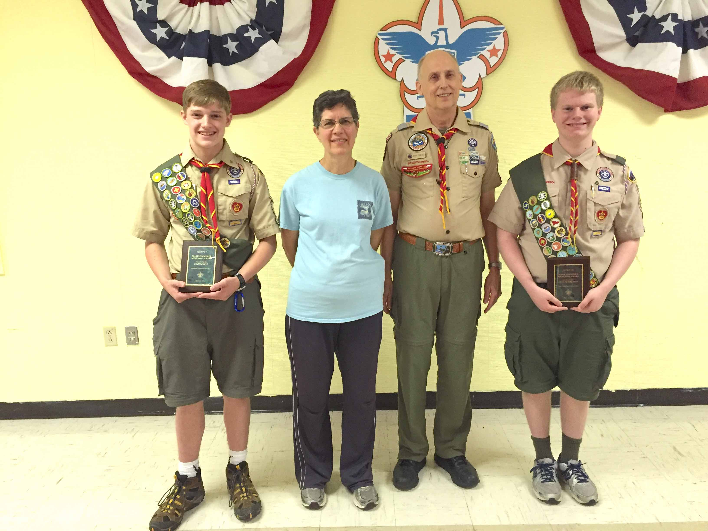
Distinguished Scout Award – Every year or so Troop 243 recognizes a scout (or scouts) as “distinguished” and we award them the Mark Zimmerer Distinguished Scout award. This award is in recognition of a truly distinguished scout from Troop 243, who died young in an accident. This year Chas Pemberton and Chris Early were chosen for that award. Both Chris and Chas are Eagle Scouts and we thank them for representing the best of our best scouts. To the right see a picture of the award winners as well as the parents Regina and Jerry Zimmer, whose son is the namesake for the award.
May Fun and Celebrations!
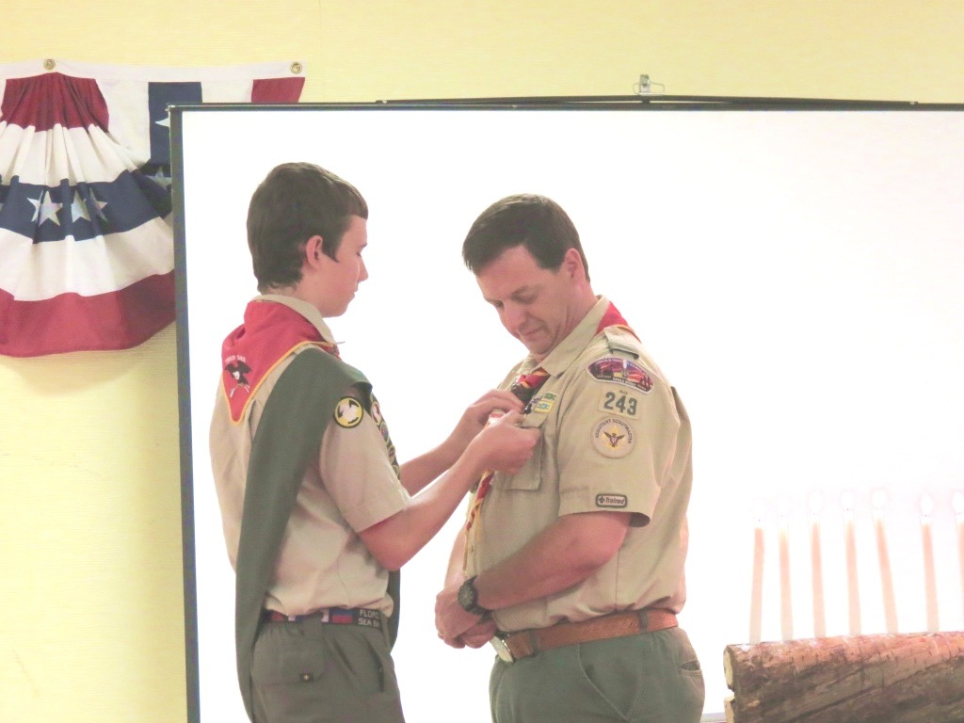
In May we celebrated Jonathan Stuecker achieving the rank of Eagle Scout. On the left here, he presents the mentor pin to the adult leader that supported him the most, Todd Early.

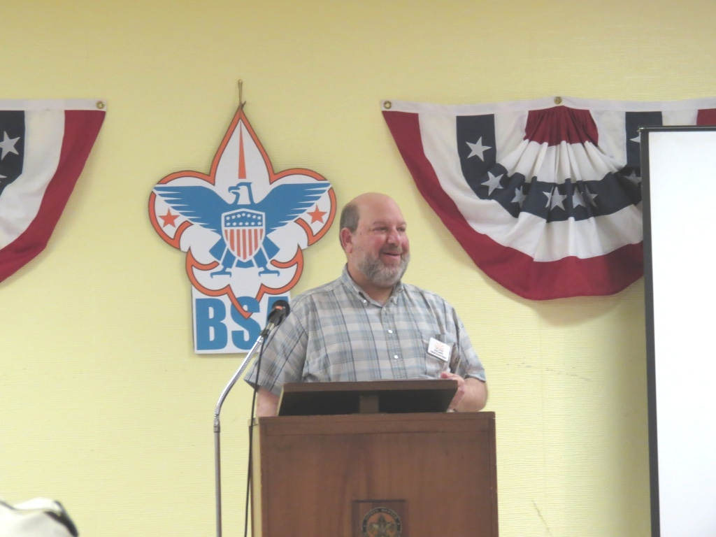

On the right is the Executive Director of Day Spring thanking Jonathan for his dedication and for choosing Day Spring to do his Eagle Project. He sees the results of Jonathan’s generosity, daily.

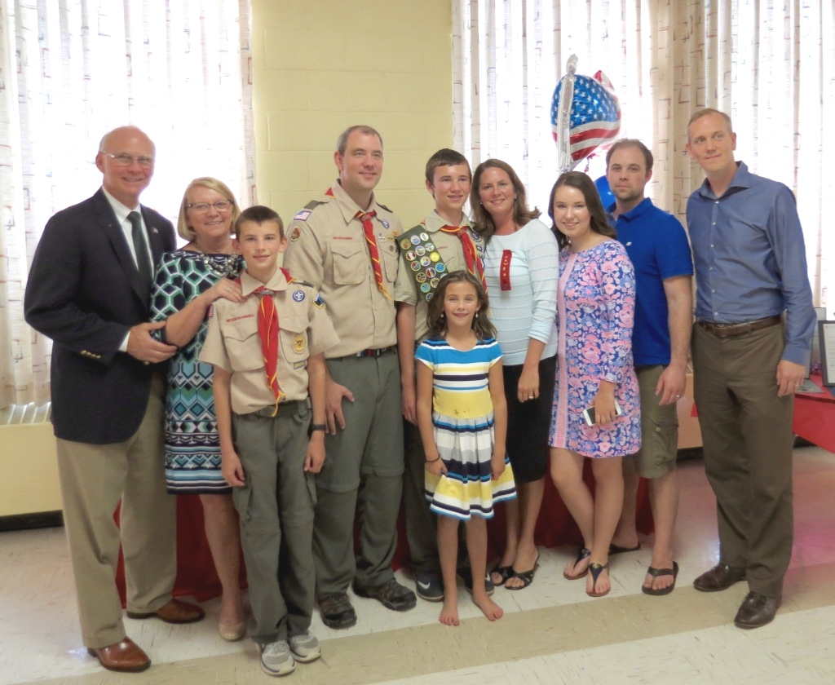
Lastly, to the left, is Jonathan’s supportive family who fulfills a key role as Jonathan progressed to the pinnacle of Boy Scouting.

Below are just a few of pictures of the most recent canoe campout. As always, this was a popular trip with great fun had by all.

